Name: ______________________________________________ Date: __________________ Period: _________

Unit 6 REVIEW Quadratics Test

Learning Target: I can rewrite quadratic functions in equivalent forms (limited to factored form and standard form: $ax^{2}+bx+c$ form).

Simplify each expression. Rewrite in the form $ax^{2}+bx+c.$
- $(3x-4)(2+3x)$ 2. $3x(3x-4)$ 3. $(2x+5)(x-12)$

Solve each quadratic equation:
4. $x^{2}+7x+6=0$ 5. $x^{2}-64=0$ 6. $3x^{2}-12x-36=0$

7. $3x^{2}+13x-10=0$ 8. ${18x}^{2}-67x+14=0$

Learning Target: I can interpret the key features in context of a quadratic function given a graph, and/or table. (note: key features include zeros, y-intercept, max/min, symmetry, size & direction)
Learning Target: I can write a quadratic function from context (limited to projectile motion).

- A ball is launched from the top of a building. The ball follows the path of $y=-16x^{2}+70x+50$ where $x$ is the time in seconds and y is the height in feet. Show your work or explain your reasoning.
- How tall is the building it is launched from, according to the equation?

- How high does the ball go? How long does it take the ball to get to the maximum height?

- When does the ball hit the ground?

- How high is the ball after 3.5 seconds?

- A child tosses a ball upward with a starting velocity of 10 ft/sec from a height of 3 ft. Show your work or explain your reasoning.
- Write an equation to find any height $x$.

- If the ball is not caught, how long will the ball be in the air?

- When will the ball reach its maximum height? What is the ball’s maximum height?

Learning Target: I can graph a quadratic function using the key features with and without technology.
- Without using your calculator, match each of the following rules with the correct graph below. All graphs are shown using the same window. Explain your reasoning in each case.
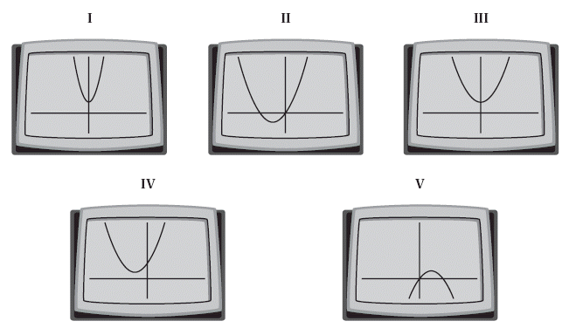
- $y=x^{2}+3x+4$

- $y=x^{2}+3x$

- $y=-x^{2}+3x$

- $y=x^{2}+3$

- $y=4x^{2}+3$

Identify the following of the function. Then draw a quick sketch of the parabola.

- $y={-x}^{2}-3x+28$

X-intercepts

y-intercepts

Axis of Symmetry

Vertex

- $y={-5x}^{2}+55x-90$

X-intercepts

y-intercepts

Axis of Symmetry

Vertex

- $y=3x^{2}-35x+11$

X-intercepts

y-intercepts

Axis of Symmetry

Vertex

Review:

- If y varies directly as x, and x = 9 when y = 15, find y when x = 33.

15. If y varies inversely as x, and y = 32 when x = 3, find x when y = 15.
16. If y varies jointly as x and z, and y = 33 when x = 9 and z = 12, find y when x = 16 and z = 22.

Factor Completely
**GCF and then factor (D.O.S or grouping)

17) 2x² - 8

18) 3x² + 4x + 4

