**For Absolute Value Functions of the Form:**

$$y=a|x -h|+k$$

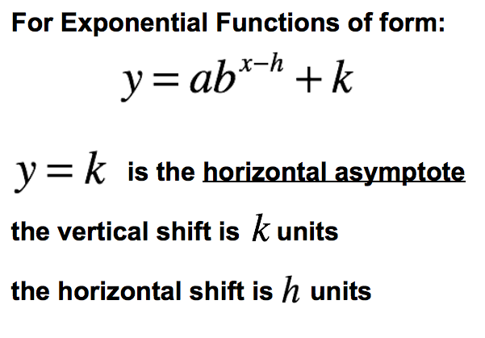

**1) If a is _______________ the graph flips verticaly**

**2) If b > 1 the graph ___________ and if 0 < b < 1 the graph ________________.**

**3) x - h moves graph _________ h units, x + h moves graph ________ h units**

**4) adding k moves the graph ______ k units, subtracting k moves the graph _______ k units**

**1) If a is _______________ the graph flips verticaly**

**2) If a > 1 the graph ___________ and if 0 < a < 1 the graph ________________.**

**3) x - h moves graph _________ h units, x + h moves graph ________ h units**

**4) adding k moves the graph ______ k units, subtracting k moves the graph _______ k units**

**For Quadratic Functions of the Form:**

$$y=a{(x-h)}^{2}+k$$

**1) If a is _______________ the graph flips verticaly**

**2) If a > 1 the graph ___________ and if 0 < a < 1 the graph ________________.**

**3) x-h moves graph _________ h units, x+h moves graph ________ h units**

**4) adding k moves the graph ______ k units, subtracting k moves the graph _______ k units**